6/24/2024

JADIN NAICKER

St10275486

CLDV6211 POE Part 3

How-To-Guide to Azure Cognitive Search

Contents

**How‐To‐Guide (HTG) which will allow future developers to integrate a cognitive search (Azure AI Search)** 2

**Introduction** 2

**Import your existing data source to integrate to your search engine.** 3

**Step 1: Start the wizard** 3

**Step 2: Connect to Data Source** 4

**Step 3: Skip Configuration for Cognitive Skills** 4

**Step 4: Configuring Your Index** 5

**Step 5: Setting Up and Running the Indexer** 6

**Step 6: Monitoring Indexer Progress** 7

**Troubleshooting Tips** 7

**Implementing Full-Text Search** 7

**Step 1: Set Up Azure AI Search** 8

**Step 2: Ingest Data** 8

**Step 3: Configure Search Settings** 8

**Step 4: Construct Search Queries** 8

**Step 5: Execute and Optimize Queries** 8

**Step 6: Monitor and Maintain** 9

**Troubleshooting tips** 10

**Using Cognitive Skills for your Azure Cognitive Search** 10

**Step 1: Configure AI Enrichment** 11

**Step 2: Document Your Configuration** 11

**Troubleshooting Tips** 12

**Conclusion** 12

**Bibliography** 18

# **Part A**

# **How‐To‐Guide (HTG) which will allow future developers to integrate a cognitive search (Azure AI Search)**

## **Introduction**

****Azure Cognitive Search is a strong cloud service by Microsoft designed for secure and scalable information retrieval. It supports both conventional and generative AI search applications, making it ideal for catalogue search, data exploration, and chat-style interfaces across proprietary data. This service offers advanced search capabilities such as vector, full-text, and hybrid searches, featuring sophisticated indexing, data chunking, vectorization, lexical analysis, and applied AI. Azure AI Search integrates seamlessly with other Azure services, facilitating automated data ingestion and enabling the development of custom AI models for tasks like image understanding and language processing. This guide helps clients integrate Azure AI Search into their websites, covering data ingestion, comprehensive text search across all fields, and enhancing search functionality with AI intelligence. (HeidiSteen, 2024)

## **Import your existing data source to integrate to your search engine.**

A data source is a repository of data for indexing and searching. It is important that data sources are well integrated to supply the search engine with meaningful content against which users can query effectively. It is essential to upload data to Azure AI Search as it enables the service to efficiently index and make the data searchable, ensuring that users can locate the information they need quickly and accurately. (Microsoft, 2024)

### **Step 1: Start the wizard**

1. Go to Azure Portal and log into the Azure portal using your Azure account credentials. (Microsoft, 2024)
2. Go to your Azure AI Search service. (Microsoft, 2024)
3. 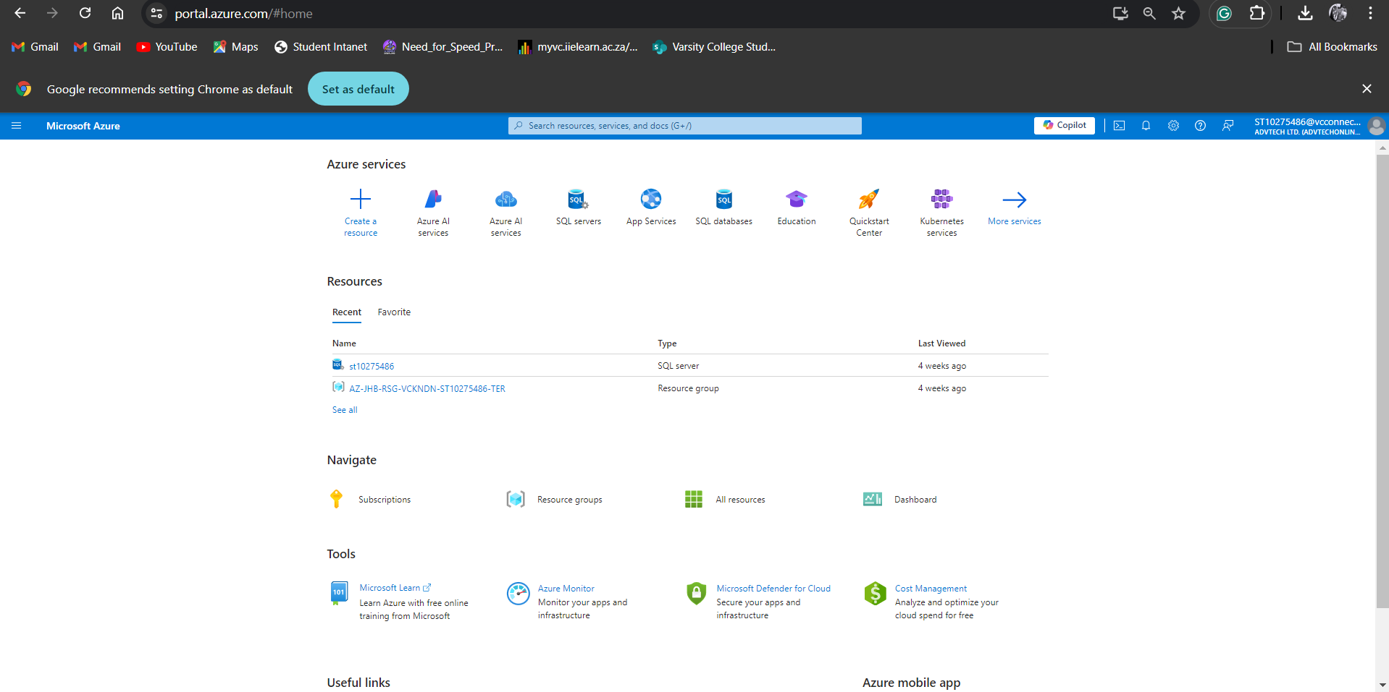On the Overview page, select **“Import data”** to start the wizard. (Microsoft, 2024)

Figure 1: User logged in Azure Portal (Microsoft, 2024)



Figure 2: : Overview page indicating "import data" on Azure AI Search service (Microsoft, 2024)

### **Step 2: Connect to Data Source**

1. Using some sample data hosted by Microsoft on Azure Cosmos DB, the information sorcerer will come up with a method to link up with data sources. (Microsoft, 2024)
2. Select sample data by expanding the data source dropdown list then select samples. After, chose your sample from the list. (Microsoft, 2024)
3. **Add cognitive skills** tocontinue (Microsoft, 2024)

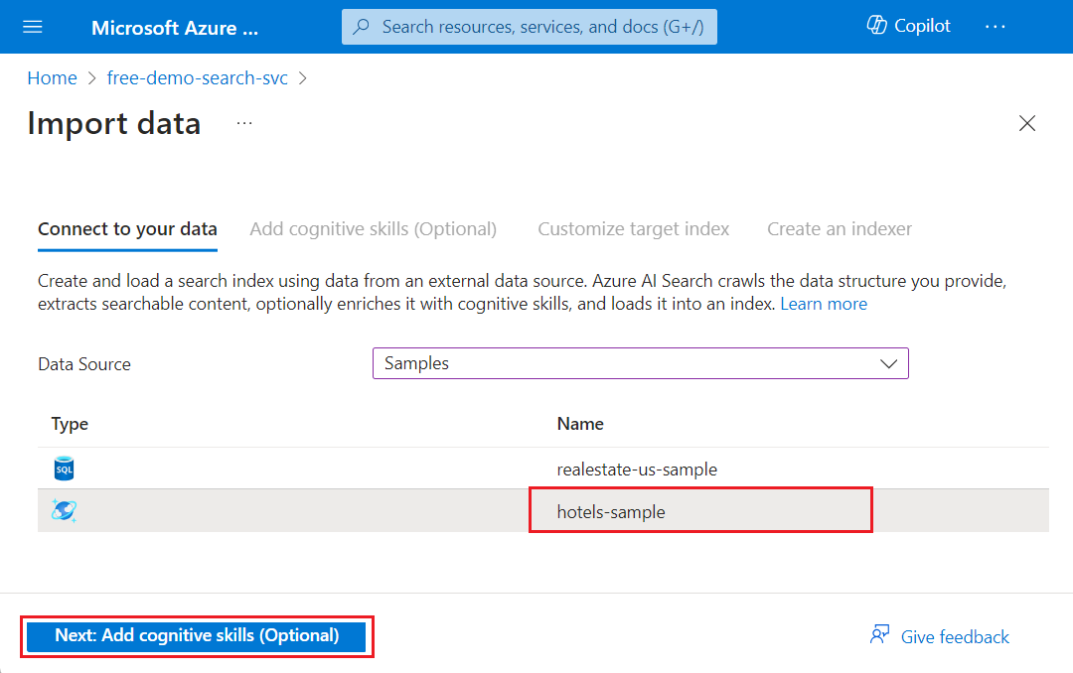

Figure 3: Connecting to a data source (Microsoft, 2024)

### **Step 3: Skip Configuration for Cognitive Skills**

1. The wizard offers options to enhance indexing with AI, but for simplicity, we'll skip this step in our quickstart. (Microsoft, 2024)
2. Select **Skip to: Customize target index.** (Microsoft, 2024)

Figure 4: Skip configuration for cognitive skills (Microsoft, 2024)

### **Step 4: Configuring Your Index**

1. Accept the defaults for Index name (YourIndexName) and Key field (YourKeyField), as well as for all field attributes as well as accepting the default settings for all field attributes. (Microsoft, 2024)
2. Click **next to create an indexer**. (Microsoft, 2024)

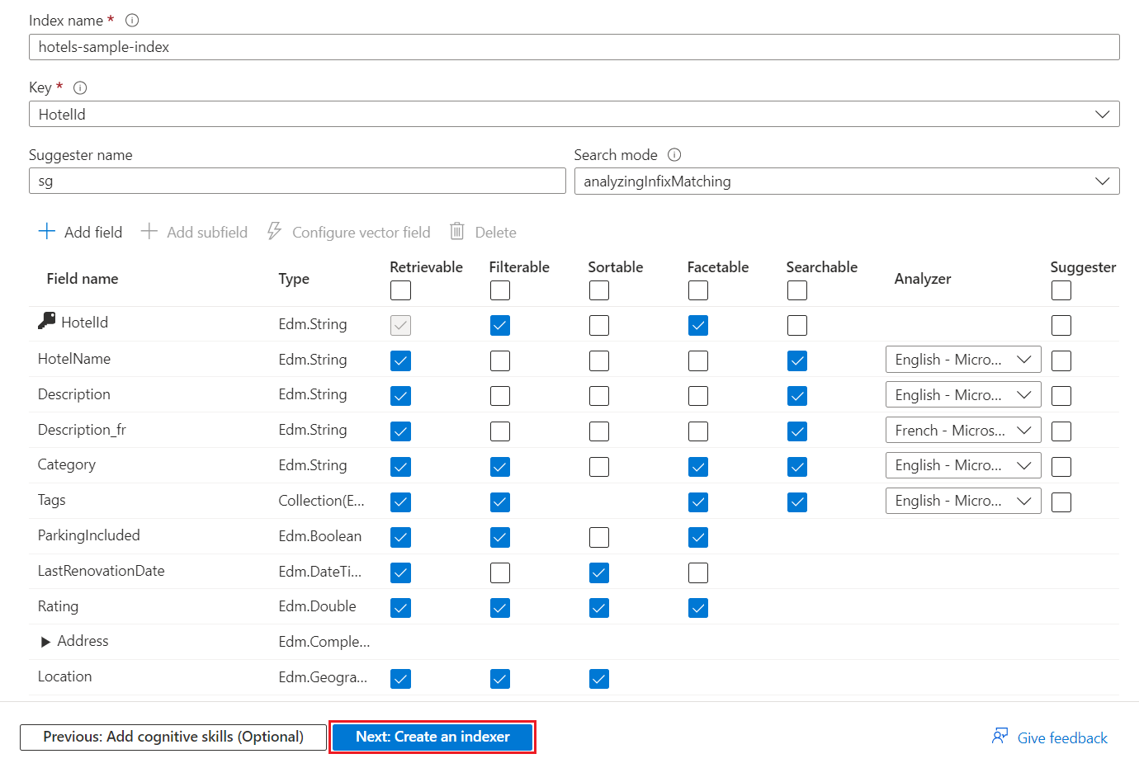

Figure 5: Configurating index, example taken from Microsoft (Microsoft, 2024)

### **Step 5: Setting Up and Running the Indexer**

1. **Default Indexer Name:** Use the default name. (Microsoft, 2024)
2. **Run the Indexer:** Opt to run the indexer once immediately, as the sample data is static with no change tracking. (Microsoft, 2024)
3. Click **Submit** to create and launch the indexer. (Microsoft, 2024)

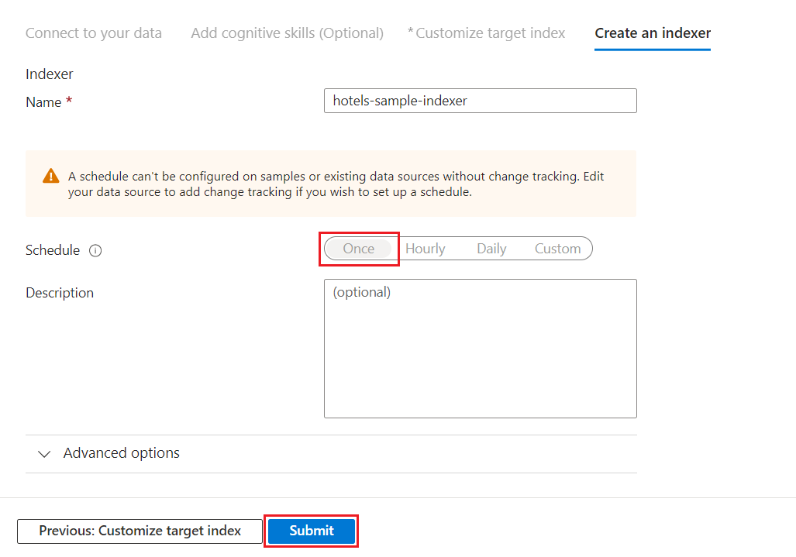

Figure 6: Run indexer. Example taken from Microsoft (Microsoft, 2024)

### **Step 6: Monitoring Indexer Progress**

1. **Watch Progress**: View the indexer or index creation progress on the Azure portal. (Microsoft, 2024)
2. 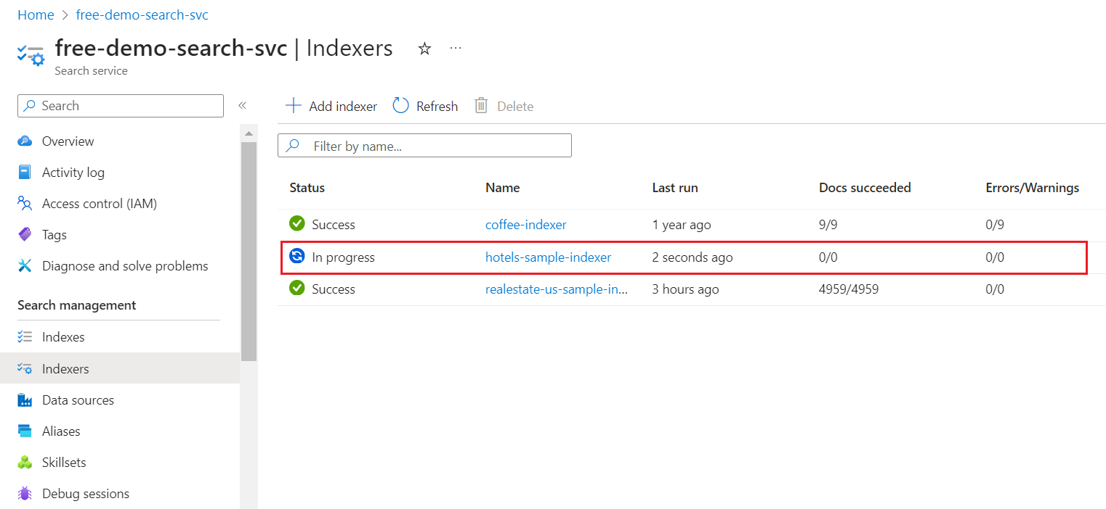To verify the status of the newly created indexer, you should go to the service Overview page and then select Indexers. The status ought to show in progress or Success. (Microsoft, 2024)

Figure 7: Monitor Indexer. Example taken from Microsoft (Microsoft, 2024)

### **Troubleshooting Tips**

* If the indexer status shows an error, check the error logs for specific issues.
* Ensure that the data source connection details are correct and accessible.
* Verify that you have not exceeded the limits of the free tier (three indexes, three data sources, and three indexers).

(Microsoft, 2024)

## **Implementing Full-Text Search**

Using Full-Text Search allows users to search through all textual content in their data, instead of only specific fields or keywords, due to full-text search. This feature improves precision and relevance in search results by allowing users to locate documents or items based on their current content. Full-text search generally includes breaking down text into individual words or tokens, creating indexes from these tokens, and facilitating efficient queries based on these indexes. (Yahnoosh, 2023)

### **Step 1: Set Up Azure AI Search**

1. Create an Azure AI Search service: If you have not yet done so, create an Azure AI Search service on your Azure portal.
2. Create search index that is suited for your needs. This search will specify fields that need to be included that are important to the kind of application you are developing, (like strings, dates, numbers, booleans etc.) therefore presenting variable ways of searches.

(Yahnoosh, 2023)

### **Step 2: Ingest Data**

1. **Import data sources**: Use Azure AI Search to connect with your data sources. Configure indexing to locate data from your desired repositories, such as Azure SQL Database.
2. Create indexers to automatically crawl and index data updates. Set up mapping between source data and the schema of your search index.

(Yahnoosh, 2023)

### **Step 3: Configure Search Settings**

1. **Choose query parsing mode:** Choose either Simple or Full Lucene query syntax depending on the nature of your application’s query needs in terms of complexity and operator assistance.
2. **Configure analysers**:  Choose the proper analysers for processing query terms and the content that has been indexed. When creating the analysers, ensure that you make them handle language-specific subtleties or industry-specific jargon.

(Yahnoosh, 2023)

### **Step 4: Construct Search Queries**

1. **Understand query structure**: Study the parts of a query including query text, query fields, filters, query modes and sorting criteria.
2. **Build search requests**: To formulate search requests, utilize Azure AI Search REST API. The search queries upshot parameters such as search texts, search fields, filters, sort orders and pagination configurations.

(Yahnoosh, 2023)

### **Step 5: Execute and Optimize Queries**

1. Put your search questions to the Azure AI Search service. Check the outcomes and modify the query parameters accordingly.
2. Track how queries are being executed and modify indexes, analysers and scoring profiles, to enhance the relevance and speed of searches.

(Yahnoosh, 2023)

### **Step 6: Monitor and Maintain**

1. Track search performance metrics, including query latency and throughput, using Azure portal monitoring tools to monitor search metrics.
2. Refine your search implementation with the input from users and data that has come from them to make it better. Adjust your search configurations and indexes to improve your user experience.

(Yahnoosh, 2023)

### **Troubleshooting tips**

* To address query accuracy issues, review and adjust search, search Fields, and search Mode parameters in search requests, analyse output from the Analyse API to understand query term processing by the analyser, and verify index settings and analyser configurations to align with expected search behaviour.
* Monitor Azure portal metrics for resource utilisation and search latency, evaluate scaling options for the Azure AI Search service, and optimize queries to enhance efficiency and reduce complexity.
* To address indexing and data consistency issues, monitor Azure AI Search indexer logs for errors, verify data source connectivity and permissions, and manually trigger index refresh if needed for data synchronization.

(Yahnoosh, 2023)

## **Using Cognitive Skills for your Azure Cognitive Search**

In Azure Cognitive Search, cognitive skills are algorithms that extract insights from content during indexing. These algorithms handle unstructured data, such as text or images, extracting metadata or enhancing content. (HeidiSteen, 2024b)

### **Step 1: Configure AI Enrichment**

1. Ensure you have the necessary Azure AI services resources, such as the Free Azure AI services for transactions based on your requirements. (HeidiSteen, 2024b)
2. 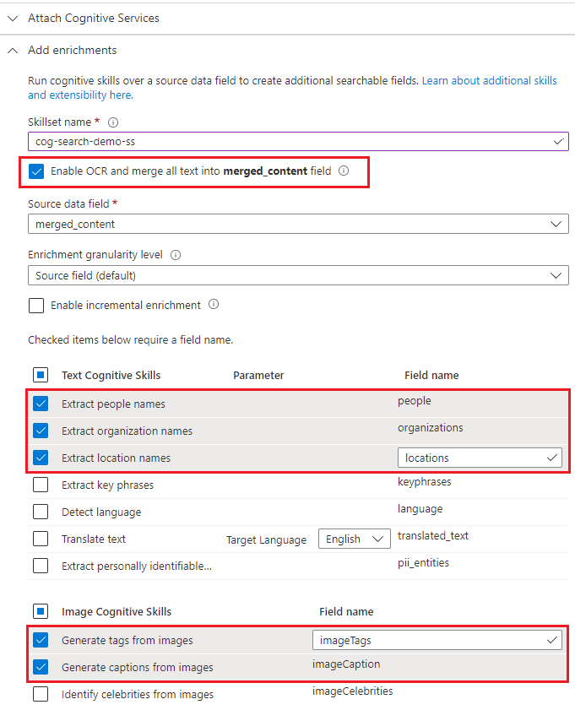Configure AI enrichment to invoke Optical Character Recognition (OCR), image analysis, and natural language processing. (HeidiSteen, 2024b)

Figure 8: Adding enrichments. Example taken from Microsoft (Microsoft, 2024)

### **Step 2: Document Your Configuration**

1. Capture a screenshot of the Skills definition page
2. Follow through with the setup process, ensuring all selected enrichments are properly integrated and configured within your Azure Cognitive Search instance.

(HeidiSteen, 2024b)

### **Troubleshooting Tips**

* Verify the integration of Azure AI Services, ensuring that OCR, image analysis, and NLP services are properly configured and connected with your Azure Cognitive Search instance for seamless functionality.
* Review Azure AI Search indexer logs for errors during data ingestion to identify and address issues related to data source connectivity, permissions, or indexing processes.
* Improve search responsiveness by optimizing queries to leverage indexed data efficiently and reduce complexity, ensuring faster and more accurate search results.

(HeidiSteen, 2024b)

## **Conclusion**

This How-To Guide aims to integrate Azure AI Search into their applications effortlessly. By following the structured steps outlined, from importing and connecting data sources to configuring indexes, implementing full-text search, and harnessing cognitive skills, it ensures a setup that enhances search functionality with AI-driven insights. Troubleshooting tips provided throughout the guide address common challenges, ensuring a smooth implementation and ongoing maintenance process. This guide equips developers with the knowledge and tools needed to use Azure AI Search effectively, enabling enhanced user experiences and optimised data retrieval capabilities for their applications.

**Part B**

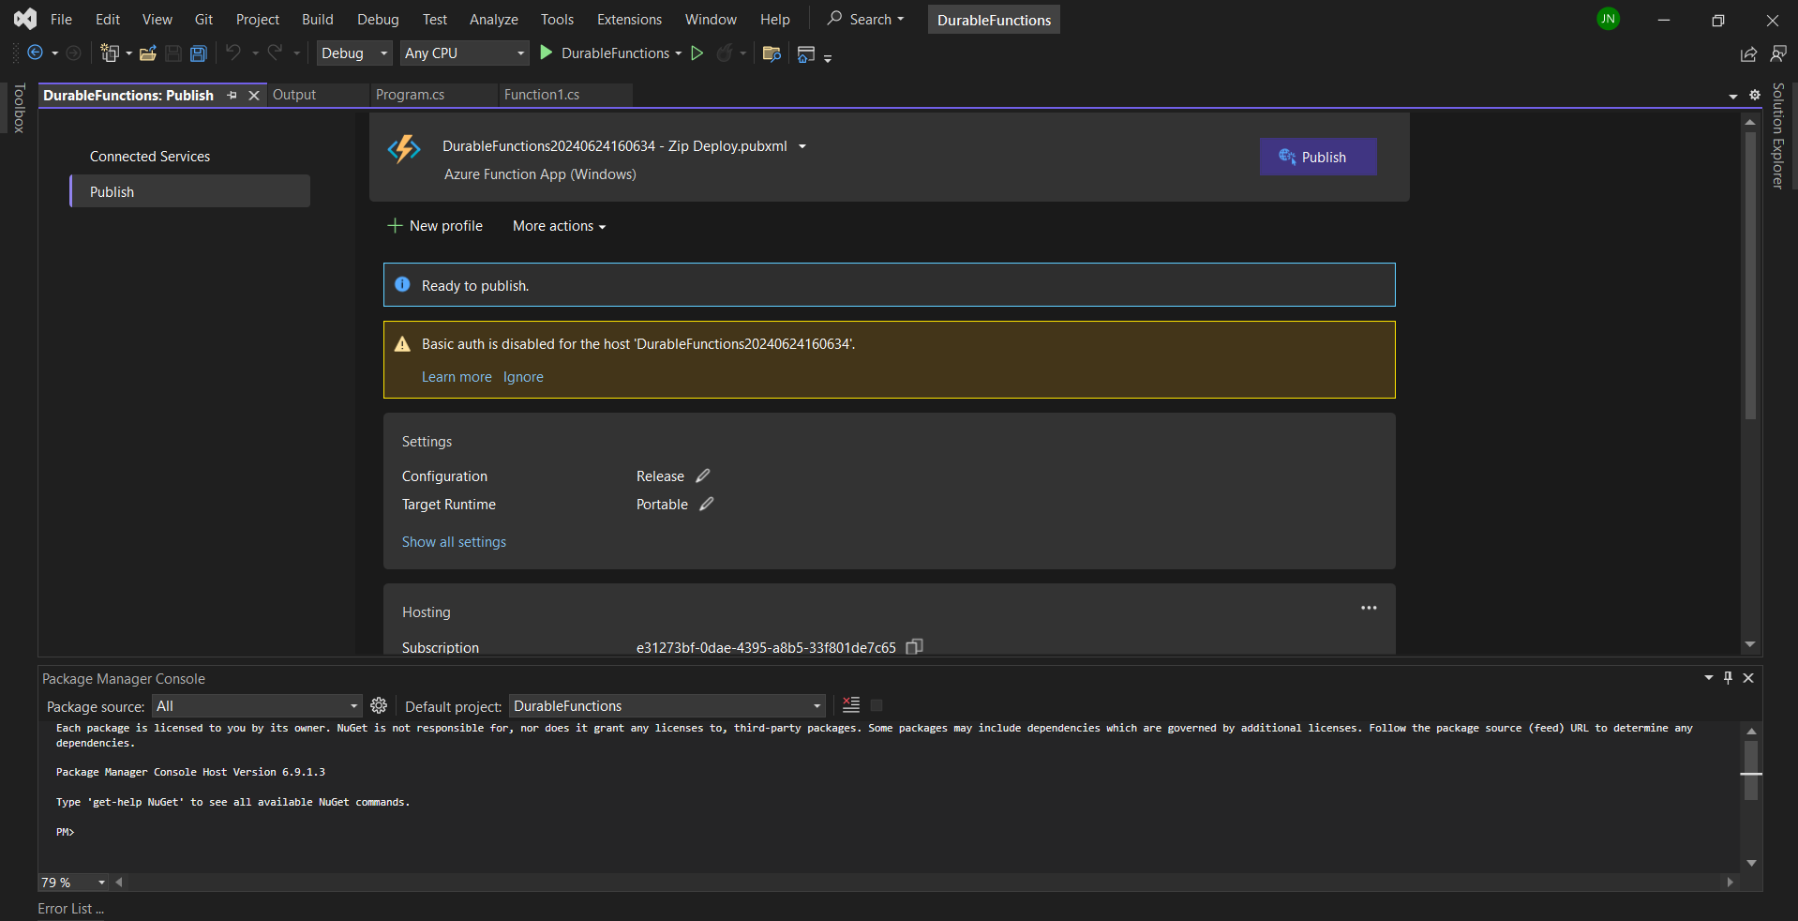These images show the durable function published to Azure

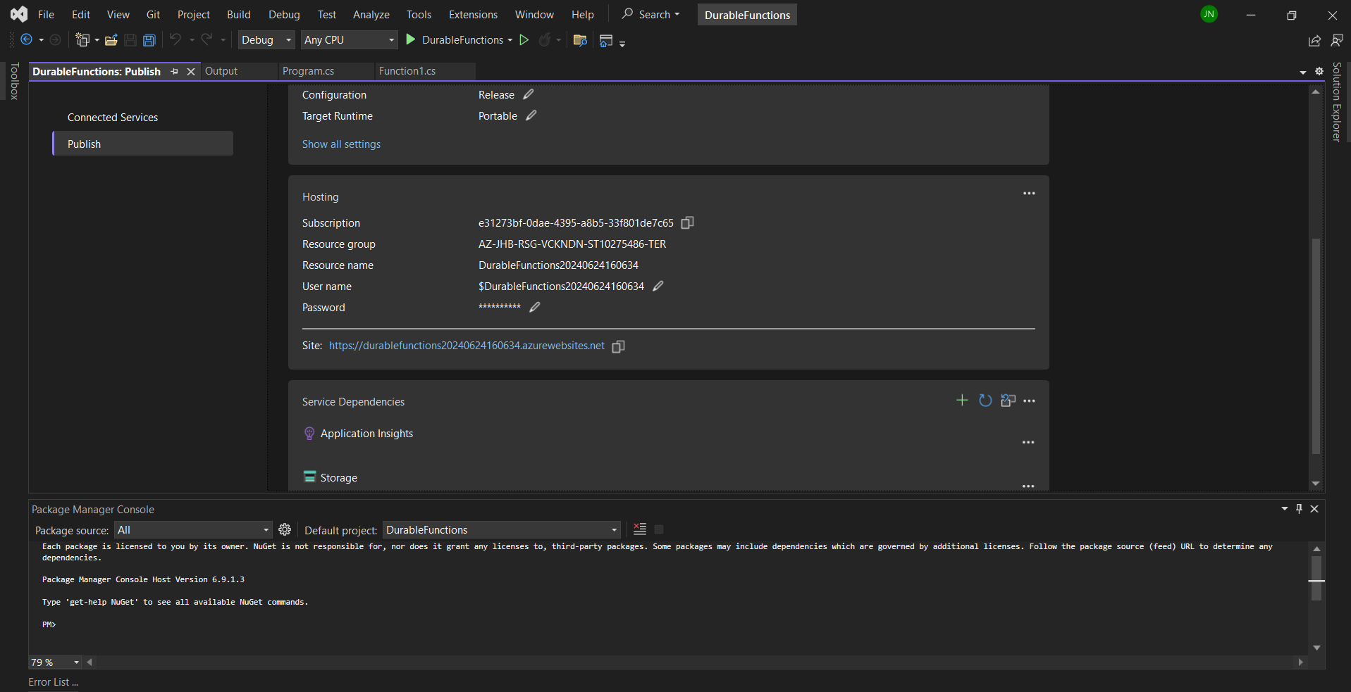

**Durable function link**: <https://durablefunctions20240624160634.azurewebsites.net>

**Website Updates**

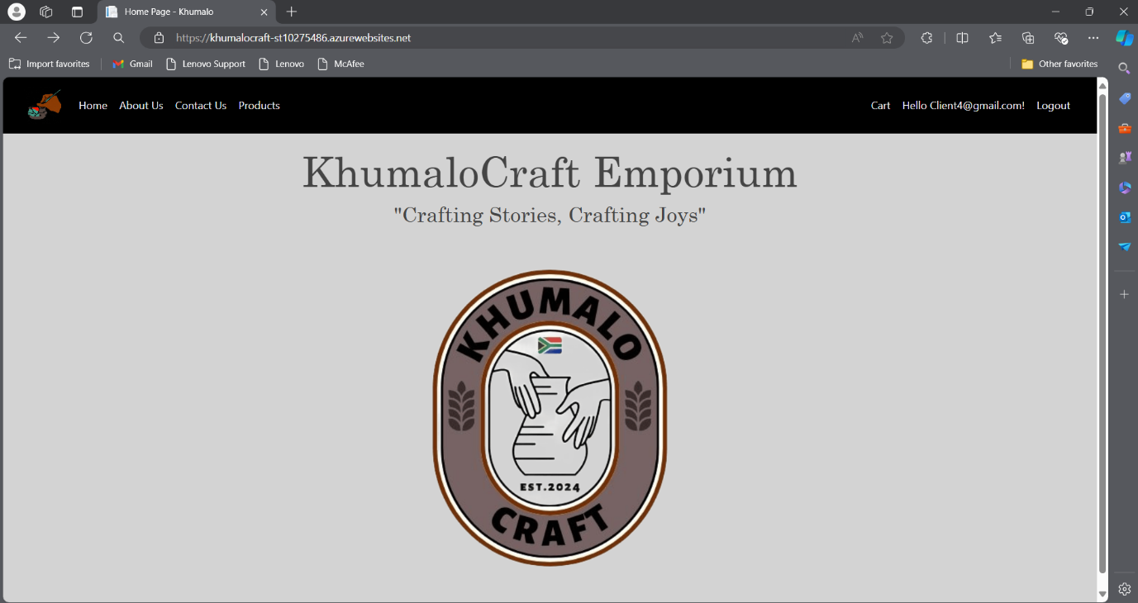**Home page**

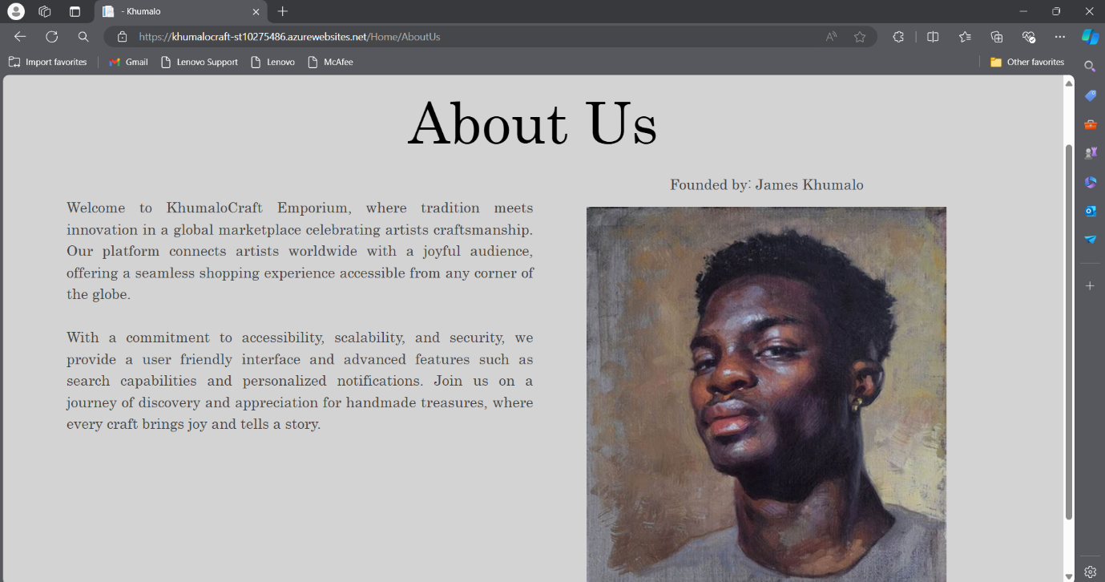**About Us Page**

**Contact Us Page**

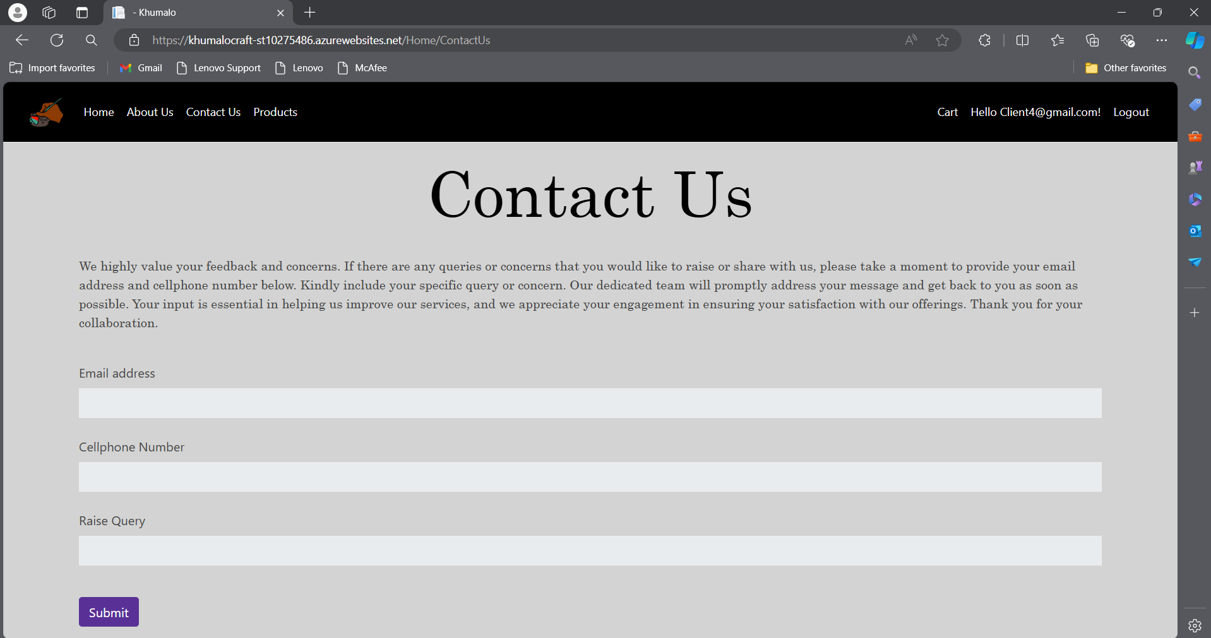**My Work Page/Product Page**

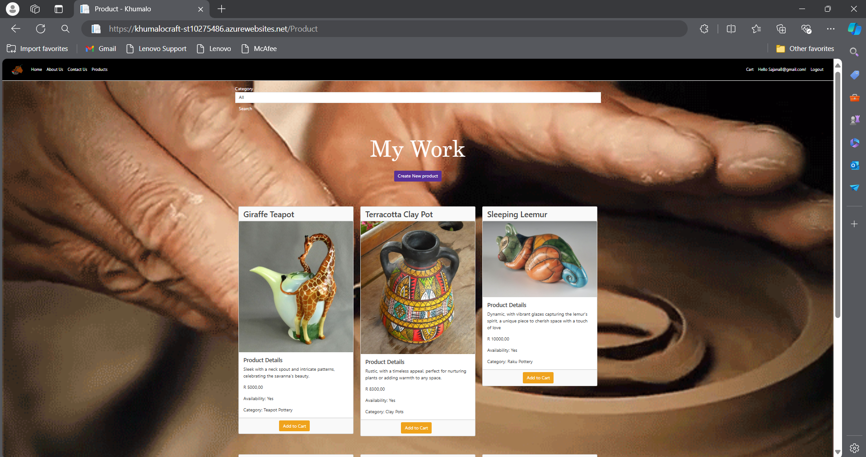

**Bonus Mark Questions**

I coded a feature where users can categorise the product they want to buy. They use the search bar on the My Work/Product page and search by category.

**Search by Category**:

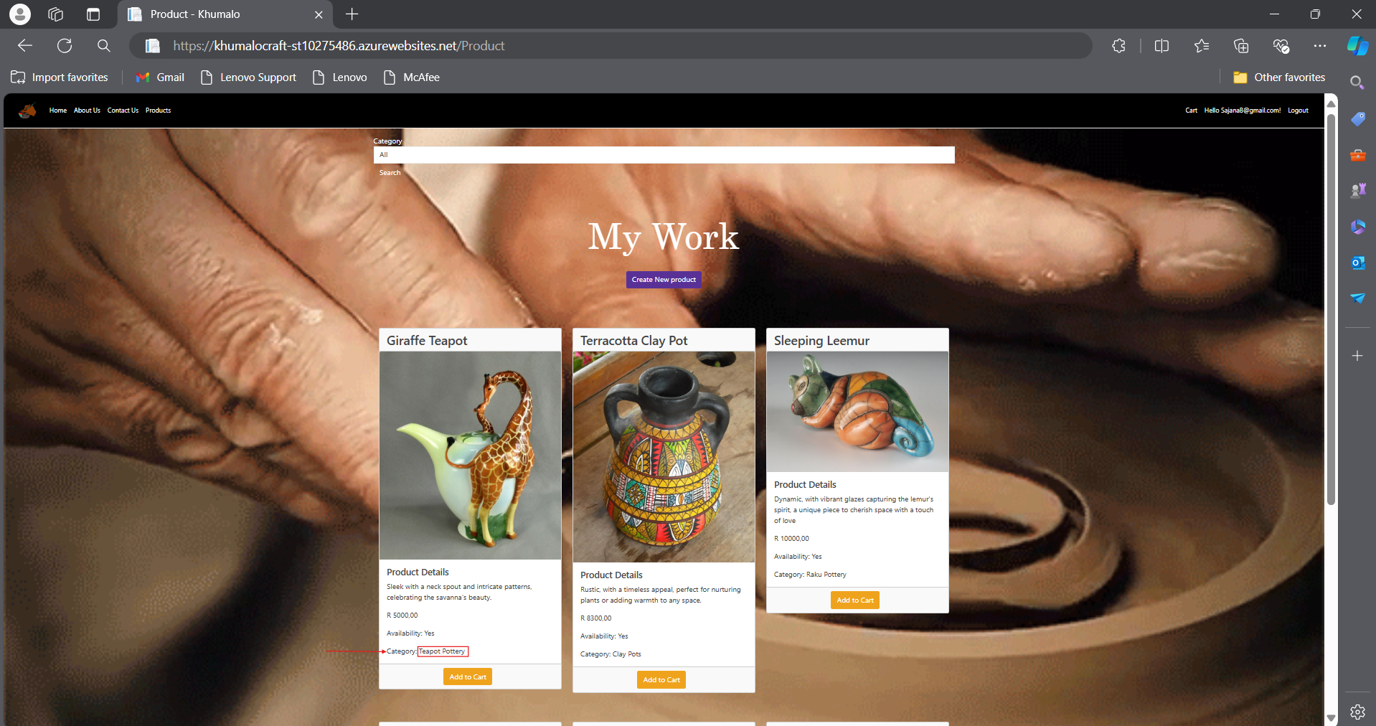

As you can see, above are the products displayed. The first product is the Giraffe Teapot

As you can see there is an arrow pointing to the category and a red box surrounding the category name. If the user couldn’t find this product, they can go to the search bar and select “Teapot Pottery” and say search, it will display all the products with the category name “Teapot Pottery”.

**Output of category search:**

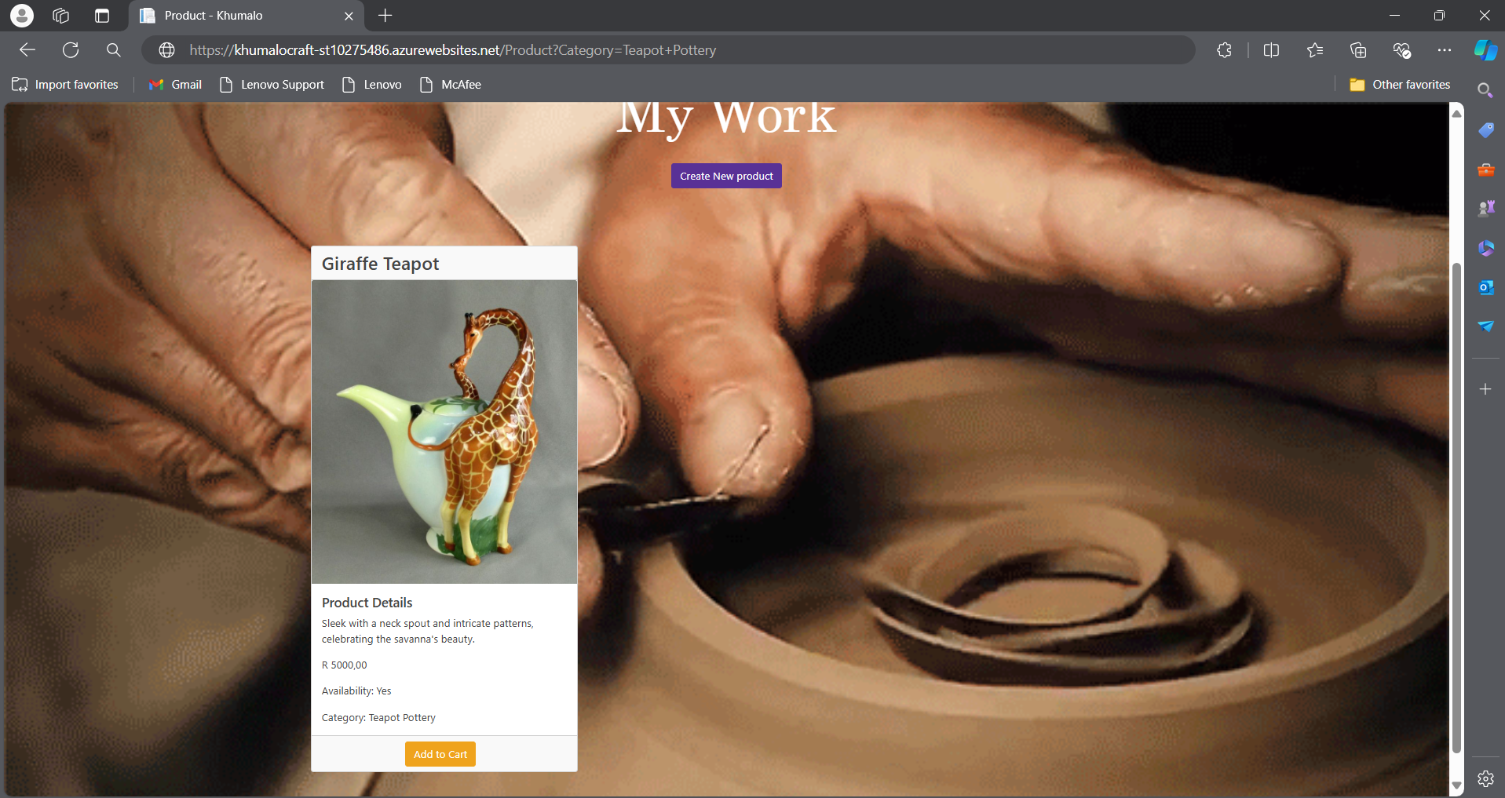

**Product Page**:

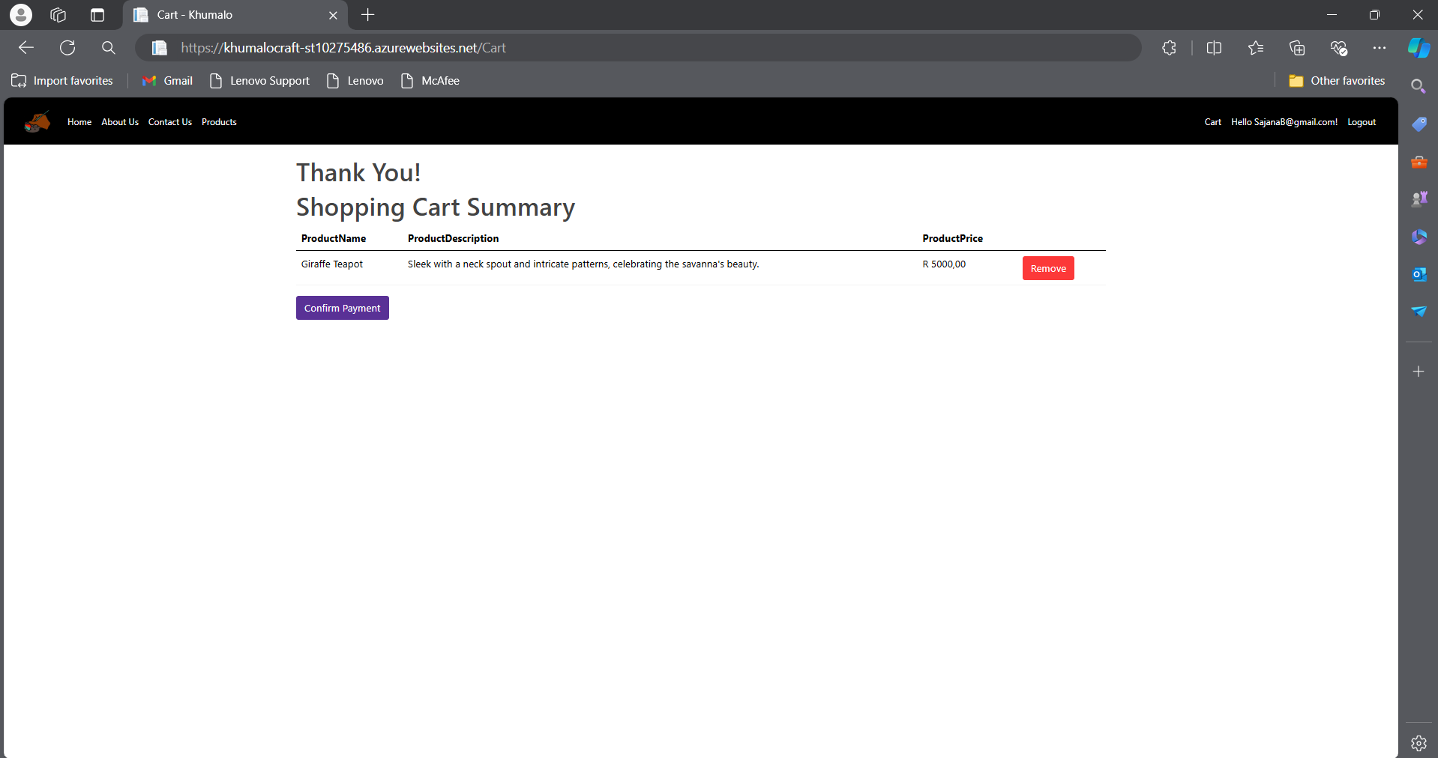

**Azure Website link**: <https://khumalocraft-st10275486.azurewebsites.net>

**GitHub Link**: <https://github.com/ST10275486-JadinNaicker/cldv6211-part-3-ST10275486-JadinNaicker.git>

## **Bibliography**

HeidiSteen (2024a). *Introduction to Azure Cognitive Search - Azure Cognitive Search*. [online] learn.microsoft.com. Available at: https://learn.microsoft.com/en-us/azure/search/search-what-is-azure-search [Accessed 6 Jun. 2024].

HeidiSteen (2024b). *Quickstart: Create a skillset in the Azure portal - Azure AI Search*. [online] learn.microsoft.com. Available at: https://learn.microsoft.com/en-us/azure/search/cognitive-search-quickstart-blob [Accessed 15 Jun. 2024].

Microsoft (2024). *Quickstart: Create a search index in the Azure portal - Azure AI Search*. [online] learn.microsoft.com. Available at: https://learn.microsoft.com/en-us/azure/search/search-get-started-portal [Accessed 18 Jun. 2024].

Yahnoosh (2023). *Full text query and indexing engine architecture (Lucene) - Azure Cognitive Search*. [online] learn.microsoft.com. Available at: https://learn.microsoft.com/en-us/azure/search/search-lucene-query-architecture [Accessed 10 Jun. 2024].